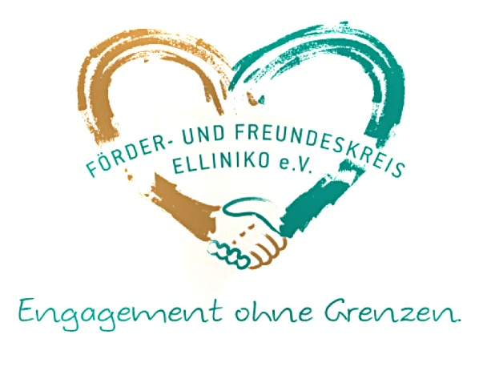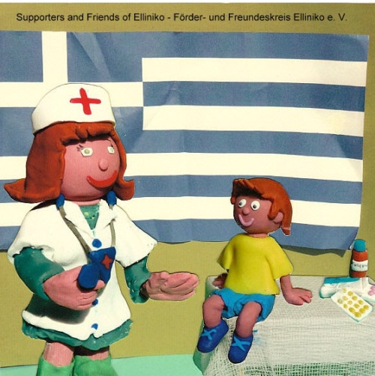

Association of Supporters and Friends of Elliniko/Förder- und Freundeskreis Elliniko e. V./
Brussels Branch

Press info – background information

The association “Supporters and Friends of Elliniko/Förder- und Freundeskreis Elliniko e. V.” is joining the numerous Brussels-based philanthropic groups seeking to support Greek civil society in a time of crisis. Below, we explain who we are, the aim of our association and how we are organising our work in Brussels and in Greece.

Who are the people behind the Association?
We are private citizens with personal ties with Greece by birth, by marriage or just because we love the country, the language and the people that have always treated us as their own. We are a group of six people, with different national backgrounds: Greek, Spanish, British and German.

To whom are we related?
We do not represent any official body or institution; we do not endorse any party or political agenda. We are committed solely to relieving the hardship that the Greek people are suffering.

The association: legal background and the aim of our work
The "Förder- und Freundeskreis Elliniko e. V." association (Supporters and Friends of Elliniko) was founded in Hamburg in 2013 and is officially registered as a non-profit organisation. Since 2015 we have also had an office in Brussels.

The background to our work:
The crisis and austerity measures have greatly increased unemployment in Greece; health insurance is granted for a maximum of 12 months after redundancy. Sufferers of chronic or severe conditions find it virtually impossible to pay for their treatment.

In November 2011, Dr. Georgios Vichas and four other doctors founded the Elliniko Social Polyclinic in southern Athens. Today, more than 300 volunteers provide free care for the sick, many of whom are in a desperate situation. Doctors from the Elliniko clinic also travel, liaising with similar clinics throughout Greece to provide urgent medical assistance to local communities and assist refugees in the newly established refugee camp in the vicinity of the Elliniko clinic.

Since 2014 we have been supporting other clinics and medical practices in Greece, particularly in the northern cities of Katerini and Thessaloniki. We also help out when public clinics cannot get vital medicines or are in urgent need of medical devices. Unfortunately, the medical situation in Greece is continuing to deteriorate, and as well as struggling to provide for its own citizens, the country is also trying to assist many thousands of refugees. We are endeavouring to link up with as many other organisations working in this area as we can to avoid duplication and ensure that medicines and medical devices go where they are most needed.

How do we organise our work in Greece?
In principle, the social polyclinics and other organisations we support do not accept any cash donations (only gifts in kind) and volunteers are not paid. We are using the money raised to buy medicine and medical products wherever possible in Greece (thus helping the Greek economy). We are also buying or receiving donations of medical equipment and are shipping it to Greece. The doctors and pharmacists in the Greek clinics inform us of their precise needs on an ongoing basis. We are constantly in touch with them, so our work is purely based on face-face-projects. NO money is transferred or spent on administrative overheads – all the people working in our association are unpaid volunteers too.

What are we doing on the spot?
The social clinics in Katerini and Athens are the main hubs, where our donations are going to. BUT: as they have created a network with other social clinics in order to help each other to cover the needs all over Greece, our donations are distributed to different places in Greece. We have thus shipped material to Kos, Mytilini, Ikaria, Crete, Larissa and other places. We also help out when public clinics cannot obtain vital medicines or are in urgent need of medical devices. Unfortunately, the medical situation in Greece is continuing to deteriorate, and as well as struggling to provide for its own citizens, the country is now also trying to assist many thousands of refugees.

Against this background, we are endeavouring to link up with as many other organisations working in this area as we can.

How do we organize our work in Brussels?
In Brussels we started our work in February 2015, organising our first charity event: a debate with the Greek doctors and an auction of Greek products More than a 100 people participated, representing the different European communities: Germans, Greeks, English, Spanish, French etc. So we were able to spread the message about the situation in the health sector in Greece to a broad community. During the year we build up our little “virtual” office. As we are all volunteers, we do not have a physical office, but we work virtually together between our frequent meetings.

Since the universities and clinics started the project “Urgences Grèce” in Brussels at the beginning of the year, they achieved a wonderful result in awareness raising about the medical and social situation in Greece. So, on the one hand we can benefit from this visibility, and on the other hand, we can join forces with these projects. The aim is to cooperate – something that is absolutely vital in order to make the best use of our combined resources- In this case, our association will donate two medical devices, worth around 4,000 EUR, for the ambulance that is being financed by the project “Urgences Grèce”.

We are in contact with doctors and hospitals, but also with pharmacists, NGOs, shops, restaurants and enterprises. With their cooperation, we are organising the collection of medicine that we will take (usually in person) to Greece, where we will distribute it among our partners.

Thanks to our different national backgrounds, we have contacts with the different, Brussels-based national communities, where we are spreading the word about the situation of the civil society in Greece. Little by little, we are contributing to awareness raising and more support is coming in.

And of course we will organise further benefit events. One of the many things we are planning to do is to bring a theatre play to Brussels, written by Dr. Yorgos Vichas, one of the founders of the social clinic in Athens, which tells the story of a sick person against the background of current situation of the Greek medical system.

What is our success story so far?
Thanks to of many people, by November 2015 the Association had raised EUR 250,000 and donations in kind worth more than EUR 300,000.

Furthermore, we were supported by many clinics and even a firm that produces materials to furbish hospitals. They donated 18 pallets of material, which were shipped to Katerini and from there were distributed to various places all over Greece.

Our main message?
We are all members of civil society and by working together, we can make all the difference in the world to the people of Greece at this difficult time. We know we are saving lives!

